The following sign templates may be customized by Partners (in languages supported) and printed by Partners to ensure community members visiting QAC/QAK locations receive information regarding location, hours, assistance available, and QAC/QAK guidelines tips.
The following signs will be provided in the 13 threshold languages at a later date. Partners may translate in additional languages to meet the language and/or accommodations (e.g., braille and large print) needs for community members using your QAC/QAK location.
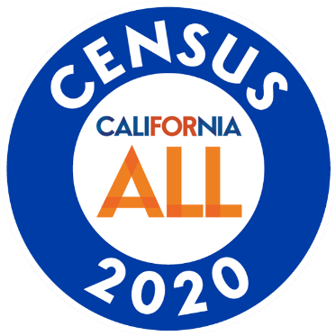

California Complete Count
Outreach Partner

If you need accommodations or in-language support, please see a member of our team for assistance.

If site is not staffed, please call the
U.S. Census Bureau at:
844-330-2020

California Complete Count
Outreach Partner

To allow for privacy of community members, please maintain a reasonable distance.

This area may be used for partner customization or may be deleted before printing.

California Complete Count
Outreach Partner

Questionnaire Assistance Center/Kiosk Tips:
- This device is provided to respond to the 2020 Census
- Ensure your online responses are entered at https://my2020census.gov/.
Tip: Look for “https” in the beginning of the website address and the image of a padlock to indicate this is a secure website.

- Misuse of devices is not allowed.
- Report suspicious activity to QAC/QAK host or team member.
- Staff & volunteers are not employees or representatives of the U.S. Census Bureau.
- The U.S. Census Bureau protects your information by law once your response is submitted.
- We encourage you to complete your questionnaire. Should you require assistance, please ask staff and volunteers for assistance as needed.
- Call the U.S. Census Bureau if you need additional assistance at: 844-330-2020
- Close the browser once your response is complete.
This area may be used for partner customization or may be deleted before printing.

California Complete Count
Outreach Partner

Questionnaire Assistance Center Operational Hours
Day of the Week | Operating Hours
Monday:
Tuesday:
Wednesday:
Thursday:
Friday:
Saturday:
Sunday:
This area may be used for partner customization or may be deleted before printing.

California Complete Count
Outreach Partner

Questionnaire Assistance Kiosk
Operational Hours
Day of the Week | Operating Hours
Monday:
Tuesday:
Wednesday:
Thursday:
Friday:
Saturday:
Sunday:
This area may be used for partner customization or may be deleted before printing.

California Complete Count
Outreach Partner

Questionnaire Assistance Center

This area may be used for partner customization or may be deleted before printing.

California Complete Count
Outreach Partner

Questionnaire Assistance Kiosk

This area may be used for partner customization or may be deleted before printing.

California Complete Count
Outreach Partner

Questionnaire Assistance Center

This area may be used for partner customization or may be deleted before printing.

California Complete Count
Outreach Partner

Questionnaire Assistance Kiosk

This area may be used for partner customization or may be deleted before printing.

California Complete Count
Outreach Partner

Questionnaire Assistance Center
This area may be used for partner customization or may be deleted before printing.

California Complete Count
Outreach Partner

Questionnaire Assistance Kiosk
This area may be used for partner customization or may be deleted before printing.

California Complete Count
U.S. Census Bureau
In-Language Phone Assistance

English  844-330-2020 | Spanish  844-468-2020
Chinese (Mandarin)  844-391-2020 | Chinese (Cantonese)  844-398-2020
Vietnamese  844-461-2020 | Korean  844-392-2020
Russian  844-417-2020 | Arabic  844-416-2020
Tagalog  844-478-2020 | Polish  844-479-2020
French  844-494-2020 | Haitian Creole  844-477-2020
Portuguese  844-474-2020 | Japanese  844-460-2020
Telephone Display Device (TDD)
844-467-2020
Note: Individuals do not need a mailer/code to respond via phone or online.

