2020 Census
Countywide Outreach Complete Count Committee (CCC) Meeting
Thursday, July 23, 2020, 9:30 a.m. to 11:30 a.m.
Skype Video Conference Meeting
To join Online: https://meet.lync.com/lacounty-ceo/mmeshack/562LTC6G
Or https://meet.lync.com/lacounty-ceo/mmeshack/562LTC6G?sl=1 via Skype Web App

To join by Telephone: (323) 776-6996, Conference ID: 145736793#

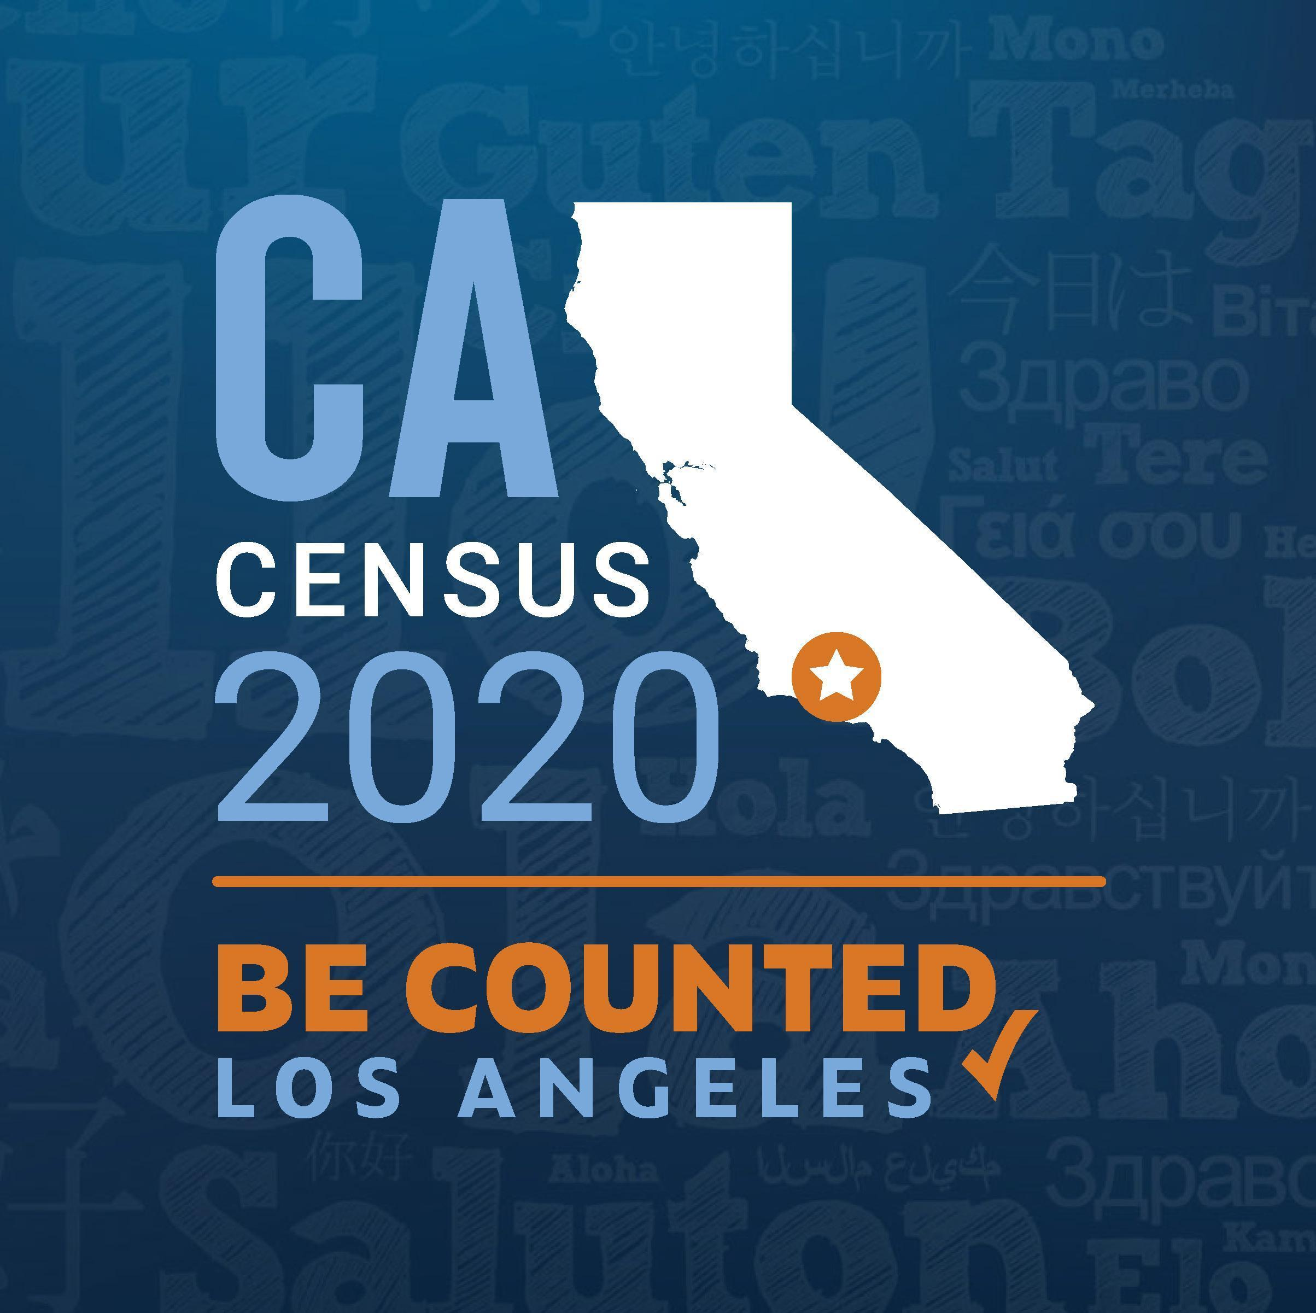
AGENDA
Meeting agendas and minutes can be found on: Census.lacounty.gov
Co-Leads: County of Los Angeles and City of Los Angeles

- Call to Order Avianna Uribe, Chief Executive Office (CEO), County of Los Angeles
Maria de la Luz Garcia, Mayor’s Office, City of Los Angeles

- Countywide Outreach CCC Updates

- LA County Outreach Updates
- Outreach Update Avianna Uribe, CEO
- Review of Los Angeles County Census Response Rates Jason Tajima, CEO
- QAC/QAK Update Marcha Stevenson, CEO

- Communication and Media Updates
- Outreach efforts to date and NRFU Plans Rachel Estrada, CEO

- Municipal Updates
- LA City Update Maria de la Luz Garcia
- Partner City Spotlight: City of Norwalk Priscilla Segura

- Community-Based Organization Outreach
- Administrative CBO, Region 8 Update Stephania Ramirez, California Community Foundation
and We Count LA Campaign

- School Districts
- Los Angeles Unified School District (LAUSD) Antonio Plasencia Jr., LAUSD
- Los Angeles County Office of Education (LACOE) Esmeralda X. Flores, LACOE

- State of CA Complete Count Office
- State Census Updates Cecil Flournoy, CA Complete Count Office

- U.S. Census Bureau Updates L.A. Regional U.S. Census Bureau
a. Non-Response Follow Up
b. Mobile Questionnaire Assistance
c. Group Quarters/Service Based Enumeration
d. Census Week of Action – July 27th

4. Questions, Answers, Announcements All

5. Public Comment

Future CCC meeting dates - 4th Thursday of every other month through September 2020:
- September 24, 2020 (Tentative); *Hosted by the City of Los Angeles

Future QAC/QAK meeting dates – Tentatively scheduled for the 3rd Wednesday of every other month
- August 19, 2020 (Tentative); *Hosted by the City of Los Angeles
- October 21, 2020 (Tentative); *Hosted by the County of Los Angeles
*Time and meeting room locations to be determined.

